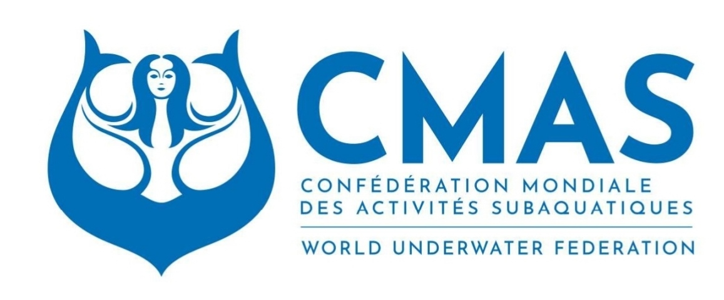**CMAS FREEDIVING WORLD CUP - DEPTH SERIES**

**CHAPTER 1**

1. Introduction:

The CMAS FREEDIVING WORLD CUP - DEPTH SERIES is envisioned as a premier CMAS worldwide freediving event that unites athletes from diverse cultures, backgrounds, and nations. The world cup series will serve as a platform to promote freediving, promote global sportsmanship, and showcase the performance of athletes across various disciplines.

1. Objectives:

Athlete Excellence, aiming to provide athletes with a stage to showcase their skills, push their limits, and compete at the highest level. The events will be spread as possible in many countries and continents so to be easier for the athletes to participate in a round near to their residence.

1. Event Structure:

Online registration: to allow athletes from all corners of the world to register and participate.

1. World Cup Rounds

The number of rounds and the places are defined annually in the CMAS calendar and identified with this label.

1. Logistics and Operations:

Security and Safety: Implement robust security measures and emergency response plans for the safety. CMAS Certified safety free divers will be used at the events.

Logistical Support: Collaborate with local authorities and professional organizers for running the event rounds and the local event logistics.

The CMAS FREEDIVING WORLD CUP DEPTH SERIES will provide World Record status aiming to set new standards for international freediving events, emphasizing to safety, organizing, and a commitment to excellence.

**CHAPTER 2**

Guidelines and specific rules for CMAS WORLD CUP DEPTH SERIES

1. Participation:

Athletes can register individually for each event

Seniors’ category only, 18 years and over

1. Registration:

All athletes must register within a specified timeframe before each event.

A limited number of 60 participants per event will be registered in the basis of first come first registered.

Registration will be online in Sportdata.

https://www.sportdata.org/cmas/set-online/index.php

Online license will be applied with cost 24 euro per participant.

1. Disciplines:

The CMAS WORLD CUP DEPTH SERIES will include the following events:

Senior Male: CWT, CWTBF, CNF, FIM

Senior Female: CWT, CWTBF, CNF, FIM

1. Rules:

The relevant CMAS rules and regulations for each discipline. Specific rules for the Depth Series will be also applied.

<https://www.cmas.org/freediving/how-to-regulations.html>

1. World Record Status:

All rounds will have World Record status.

1. Scoring and Classification System:

CWT:1 point per meter

CWTBIFINS:1 point per meter

FIM:1 point per meter

CNF: 1.25 points per meter

Event medals

3 first places for men and women in each discipline in each round

Overall winner of each WORLD CUP round.

There will be an overall ranking for each round as follows:

The athlete with the best sum, adding points from his best performances, from all 4 discipline or from less if he has not participated at all disciplines.

Even If an athlete has not participated at all events, his total score counts at the event ranking.

e.g

CWT:100 mt=100 points

CWTBIFINS:95 mt =95 points

FIM:100 mt =100 points

CNF: 80mtx1,25= 100 points

Total 395 points

* Total CMAS WORLD CUP DEPTH SERIES Classification:

Calculating Total Points:

For each participant, adding the total points earned in their two best events.

Overall, Winner of the CMAS FREEDIVING WORLD CUP DEPTH SERIES:

The athlete with the highest total points based on his best two events is declared the overall DEPTH SERIES Winner.

1. Program

Each event can be from 4 to 9 competition days. A rest day after two competition days is mandatory. Every athlete can choose the discipline that wants to compete. Athletes can compete in the same discipline as many competition days they want. Mixed discipline starts are allowed. The relevant rules are applied.

1. Participation fees

Suggestion 120 euro/dollar per competition day